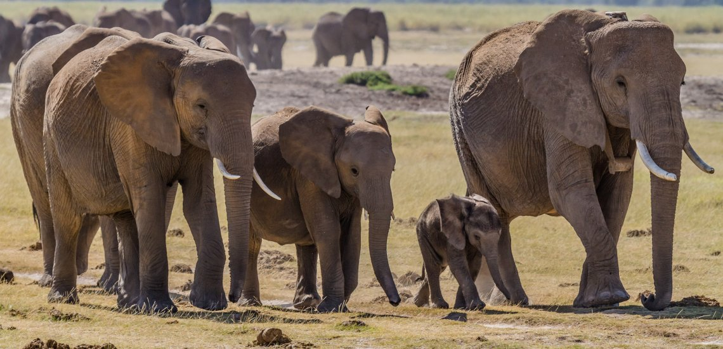
Wildlife and Climate Change
Herd of elephants © Benh Lieu
Song
For the past twenty years, climate change has been high on the international agenda. Together with desertification, soil degradation and biodiversity loss, it is widely recognized as the major environmental threat the world is facing. Evidence is increasing that warming and other climate-related changes are happening more quickly than anticipated, and prognoses are becoming worse.
The world already faces a biodiversity extinction crisis, and it is likely to be made worse by climate change. Therefore, terrestrial, freshwater and marine wildlife will be severely affected unless we manage to cope with climate changes through decisive planning and action. The main focus is on tropical terrestrial wildlife and its habitats, but other fauna, ecosystems and geographical regions are covered as well.
The impacts of climate change will include permanent changes in physical conditions, such as snow cover, permafrost and sea level along with increases in both the irregularity and severity of extreme weather events like droughts, floods and storms, which will lead to changes in ecosystems and ecosystem functioning.
The world is undergoing an extinction crisis – the most rapid loss of biodiversity in the planet’s history – and this loss is likely to accelerate as the climate changes.
It has been estimated that 20–30 percent of plant and animal species will be at higher risk of extinction due to global warming and that a significant proportion of endemic species may become extinct by 2050 as a consequence. Some taxa are more susceptible than others. For example, 566 of 799 warm-water reef-forming coral species are at risk of becoming endangered because of the increasing climate change, as are about 35 percent of birds and 52 percent of amphibians. Moreover, the impact will likely be more severe on species that are already at risk of extinction: 70–80 percent of red-listed birds, amphibians and corals are considered susceptible to the effects of climate change (Vié, Hilton-Taylor and Stuart, 2008).
As average global temperatures rise, the impacts on habitats and species will depend on many factors, including local topography, changes in ocean currents, wind and rainfall patterns and changing albedo. In addition to variations in the rate and extent of temperature increases at different latitudes, there may be changes in the length and severity of seasons, including decreases in temperature in some areas. Rainfall patterns may likewise be affected in terms of overall annual quantity, seasonal distribution of precipitation and year-by-year regularity. Extreme weather events, such as droughts and floods, are expected to occur more often. In particular, droughts are projected to become more frequent and intense in subtropical and southern temperate forests; this will increase the prevalence of fire and predisposition to pests and pathogens (Seppälä, Buck and Katila, 2009).
Non-timber forest resources, such as fuelwood, charcoal, non-wood forest products and wildlife sustain the livelihoods of hundreds of millions of people in forest-dependent communities. Most rural and many urban populations in developing countries rely on woody biomass as their main energy source and depend on wild plant medicines for their healthcare. In many developing countries, bushmeat is an important source of protein, while for coastal communities or those living near freshwater, fish can be a major source of protein. In Central Africa, there is a very large and well-established trade in bushmeat products, which is driven mainly by consumer demand in major cities. Up to 5 million tonnes of bushmeat are believed to be consumed every year in the Congo Basin (Fa et al., 2002; Kleine, Buck and Eastaugh, 2010; Seppäla, Buck and Katila, 2009) in a trade that is recognized as unsustainable and often illegal. Despite their importance to local communities, about 13 million hectares (ha) of the world’s forests are lost due to deforestation each year (FAO, 2010a) and further large areas are also degraded. Richardson & Robinson, 2005).

Major climate-induced changes
Increased temperatures affect physical systems, as ice melts and snow cover is reduced, as well as affecting biological systems through a series of direct and indirect pressures. Physical systems include deep snow, glaciers and permafrost. Increases in temperature can lead to a drastic unbalancing of the physical system, causing irreversible losses.
The water cycle and hydrological systems are affected by changing temperatures, often indicated by dry riverbeds or floods due to increased runoff. In semi-desert areas, the decreased availability of water is already placing additional pressures on wildlife, which aggregate around limited water points and compete with domestic livestock (de Leew et al., 2001). Reduced plant production as a consequence of reduced precipitation increases the probability of soil degradation due to overgrazing by wildlife and domestic animals. Many freshwater species are under serious threat of extinction as a result of rising temperatures and the disappearance of ponds and coastal lagoons (Willets, Guadagno and Ikkala, 2010).
Rising sea levels are affecting coastal areas through shoreline erosion, the loss of coastal wetlands and modification of coastal vegetation. Marine and coastal ecosystems are also disrupted by storms that damage corals directly through wave action and indirectly through light attenuation by suspended sediment and abrasion by sediment and broken corals.
Higher temperatures also cause the expulsion of zooxanthellae (single-celled plants living in the cells of coral polyps), which leads to coral bleaching and has caused the loss of 16 percent of the world’s corals (Wilkinson, 2004). Up to a third of corals are considered to be threatened with extinction due to climate change (Carpenter et al., 2008). In a chain reaction, the death of corals causes the loss of habitat for many species of tropical fish. Many studies report changes in fish populations, recruitment success, trophic interactions and migratory patterns related to regional environmental changes due to changing climatic conditions (e.g. Edwards and Richardson, 2004; Hays, Richardson & Robinson, 2005).
Photo Resources: © Global Warming Images/WWF; © Jurgen Freund/WWF; © Simon de Trey-White/WWF-UK; © Brent Stirton/WWF
Major threats to biodiversity
- Habitat destruction
- Overexploitation
- Invasive species
- Pollution
- Climate change

What makes a species vulnerable to climate change?
SENSITIVITY
- IUCN Red list status
- Geographic range
- Population size
- Temperature tolerance
- Reliance on environmental cues (for reproduction, migration, hibernation)
- Strong interactions with other species
- Diet
- Abundance of food source
- Freshwater requirements
- Habitat specialization
- Susceptibility to disease
The different traits are considered under the “sensitivity” category. Species with the following traits would be considered to have a HIGH vulnerability to climate change: Endangered on the IUCN Red list, narrow geographic range, small population size, narrow temperature tolerance, strong dependence on environmental cues for reproduction, migration and hibernation, strong interactions with one or more species (e.g. symbiosis), specialist diet, low abundance of food source, high freshwater requirements, specific habitat requirements, and high susceptibility to disease.

What makes a species vulnerable to climate change?
Adaptive capacity
- Dispersal ability
- Generation time
- Reproductive rate
- Genetic variation

Elephants and water
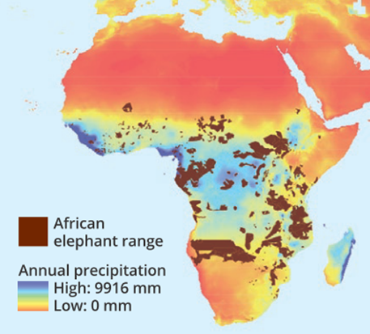
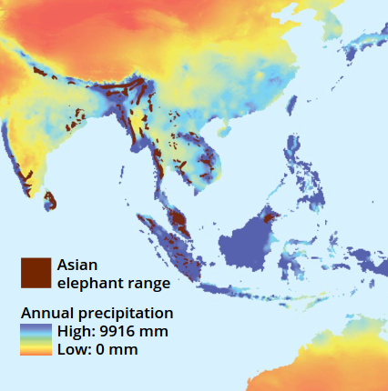
Photo Resources: © Nikhil Advani/WWF

Consequences of Climate Change
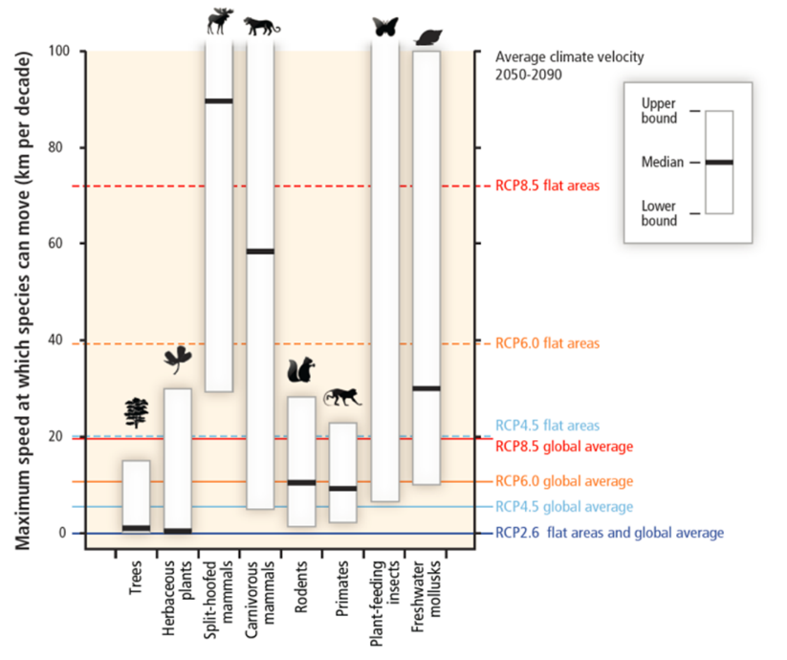
The IPCC has predicted that, as a result of changes in rainfall patterns and average global temperatures, “during the course of this century, the resilience of many ecosystems (their ability to adapt naturally) is likely to be exceeded by an unprecedented combination of change in climate and in other global change drivers (especially land use change and overexploitation), if greenhouse gas emissions and other changes continue at or above current rates. By 2100, ecosystems will be exposed to atmospheric CO2 levels substantially higher than in the past 650 000 years, and global temperatures at least among the highest as those experienced in the past 740 000 years. This will alter the structure, reduce biodiversity and perturb functioning of most ecosystems, and compromise the services they currently provide” (Parry et al., 2007).
Coastal inundation and salination is another landscape-level effect of climate change as sea levels steadily rise. Low-lying terrestrial ecosystems in the tropics will be increasingly exposed to storm surges as coral reefs decline.
Source and more information:
Vié, J.-C., Hilton-Taylor, C. & Stuart, S.N. 2008. Wildlife in a changing world: an analysis of the 2008 IUCN Red List of Threatened Species. Gland, Switzerland, IUCN. 180 pp. (also available at iucn.org/about/work/programmes/species/red_list/review/).
Seppälä, R., Buck, A. & Katila, P., eds. 2009. Adaptation of forests and people to climate change: a global assessment report. IUFRO World Series, 22. Helsinki, International Union of Forest Research Organizations.
Hays, G.C., Richardson, A.J. & Robinson, C. 2005. Climate change and marine plankton. Trends in Ecology and Evolution,

