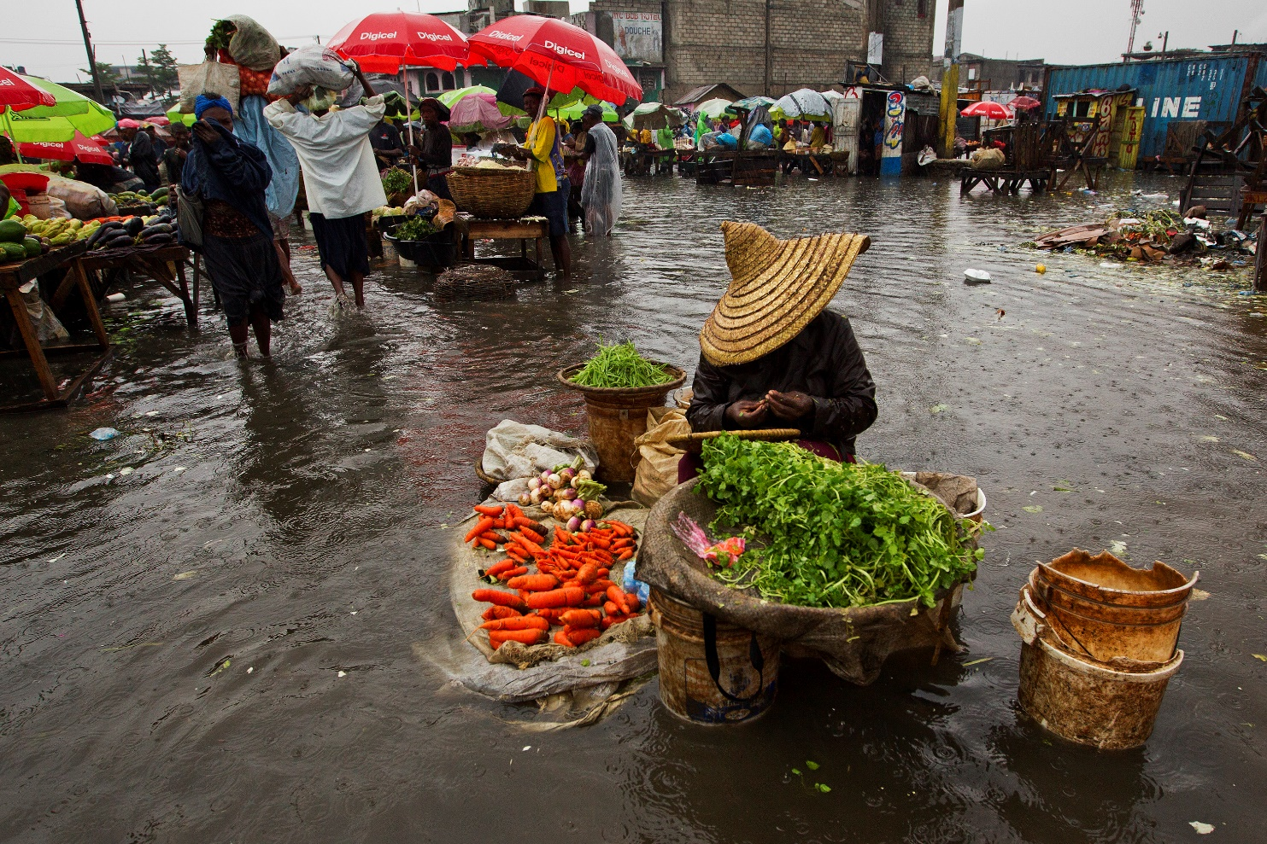
Food shortage
Creator: UN Photo/Logan Abassi
Climate change will affect all four dimensions of food security: food availability, food accessibility, food utilization and food systems stability. It will have an impact on human health, livelihood assets, food production and distribution channels, as well as changing purchasing power and market flows. Its impacts will be both short term, resulting from more frequent and more intense extreme weather events, and long term, caused by changing temperatures and precipitation patterns. People who are already vulnerable and food insecure are likely to be the first affected.
Agriculture-based livelihood systems that are already vulnerable to food insecurity face immediate risk of increased crop failure, new patterns of pests and diseases, lack of appropriate seeds and planting material, and loss of livestock. People living on the coasts and floodplains and in mountains, drylands and the Arctic are most at risk.
As an indirect effect, low-income people everywhere, but particularly in urban areas, will be at risk of food insecurity owing to loss of assets and lack of adequate insurance coverage.
This may also lead to shifting vulnerabilities in both developing and developed countries. Food systems will also be affected through possible internal and international migration, resource- based conflicts and civil unrest triggered by climate change and its impacts.
Agriculture, forestry and fisheries will not only be affected by climate change, but also contribute to it through emitting greenhouse gases. They also hold part of the remedy, however; they can contribute to climate change mitigation through reducing greenhouse gas emissions by changing agricultural practices.
At the same time, it is necessary to strengthen the resilience of rural people and to help them cope with this additional threat to food security. Particularly in the agriculture sector, climate change adaptation can go hand-in-hand with mitigation. Climate change adaptation and mitigation measures need to be integrated into the overall development approaches and agenda.

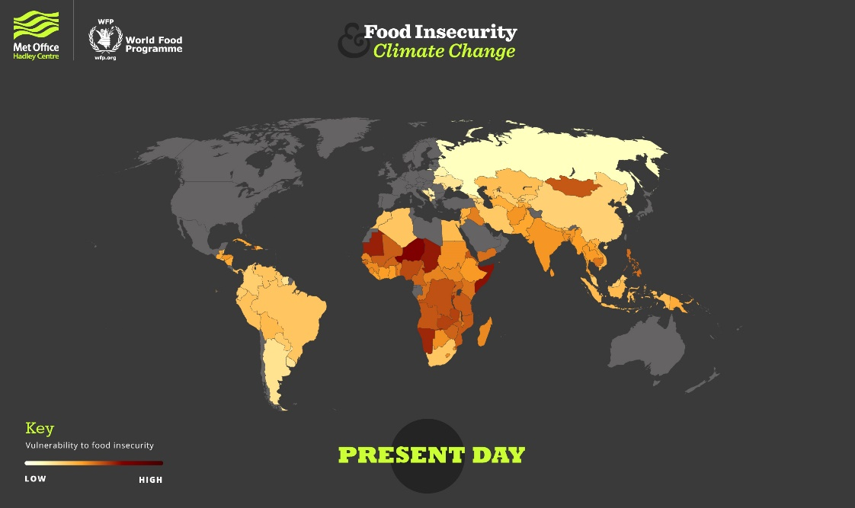
Vulnerability to food insecurity: present day
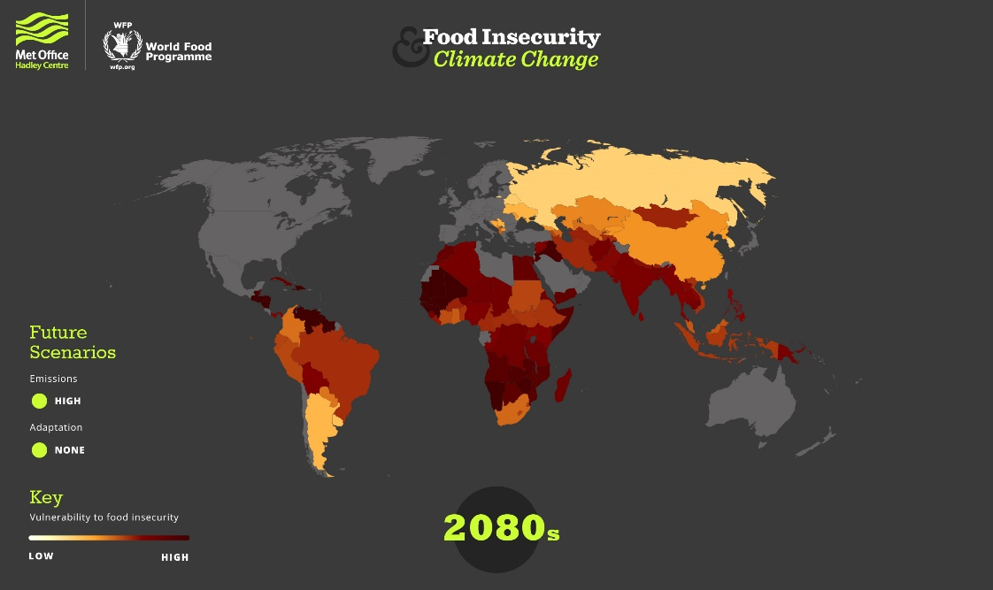
Vulnerability to food insecurity: 2080s projection
https://www.metoffice.gov.uk/food-insecurity-index/

A wider point of view
Mean global temperatures have been increasing since about 1850. The process of global warming shows no signs of abating and is expected to bring about long-term changes in weather conditions.
Effects are already being felt in global food markets and are likely to be particularly significant in specific rural locations where crops fail and yields decline.
Until about 200 years ago, climate was a critical determinant for food security. Since the advent of the industrial revolution, however, humanity’s ability to face the forces of nature and manage its own environment has grown enormously. As long as the economic returns justify the costs, people can now create artificial microclimates, breed plants and animals with desired characteristics, enhance soil quality, and control the flow of water.
Advances in storage, preservation and transport technologies have made food processing and packaging a new area of economic activity. This has allowed food distributors and retailers to develop long-distance marketing chains that move produce and packaged foods throughout the world at high speed and relatively low cost. Where supermarkets with a large variety of standard-quality produce, available year-round, compete with small shops selling high-quality but only seasonally available local produce, the supermarkets generally win out. The consumer demand that has driven the commercialization and integration of the global food chain derives from the mass conversion of farmers into wage-earning workers and middle-level managers, which is another consequence of the industrial revolution. Today, food insecurity persists primarily in those parts of the world where industrial agriculture, long-distance marketing chains and diversified non-agricultural livelihood opportunities are not economically significant.
At the global level, therefore, food system performance today depends more on climate than it did 200 years ago; the possible impacts of climate change on food security have tended to be viewed with most concern in locations where rainfed agriculture is still the primary source of food and income.
However, this viewpoint is short-sighted. It does not take account of the other potentially significant impacts that climate change could have on the global food system, and particularly on market prices. These impacts include those on the water and energy used in food processing, cold storage, transport and intensive production, and those on food itself, reflecting higher market values for land and water and, possibly, payments to farmers for environmental services.
Rising sea levels and increasing incidence of extreme events pose new risks for the assets of people living in affected zones, threatening livelihoods and increasing vulnerability to future food insecurity in all parts of the globe. Such changes could result in a geographic redistribution of vulnerability and a relocalization of responsibility for food security – prospects that need to be considered in the formulation of adaptation strategies for people who are currently vulnerable or could become so within the foreseeable future.
The potential impacts of climate change on food security must therefore be viewed within the larger framework of changing earth system dynamics and observable changes in multiple socio-economic and environmental variables.

Climate change and food security
Agriculture is important for food security in two ways: it produces the food people eat; and (perhaps even more important) it provides the primary source of livelihood for 36 percent of the world’s total workforce. In the heavily populated countries of Asia and the Pacific, this share ranges from 40 to 50 percent, and in sub-Saharan Africa, two-thirds of the working population still make their living from agriculture (ILO, 2007).
Agriculture, forestry and fisheries are all sensitive to climate. Their production processes are therefore likely to be affected by climate change. In general, impacts are expected to be positive in temperate regions and negative in tropical ones, but there is still uncertainly about how projected changes will play out at the local level, and potential impacts may be altered by the adoption of risk management measures and adaptation strategies that strengthen preparedness and resilience.

The food security implications of changes in agricultural production patterns and performance are of two kinds:
- Impacts on the production of food will affect food supply at the global and local levels. Globally, higher yields in temperate regions could offset lower yields in tropical regions. However, in many low-income countries with limited financial capacity to trade and high dependence on their own production to cover food requirements, it may not be possible to offset declines in local supply without increasing reliance on food aid.
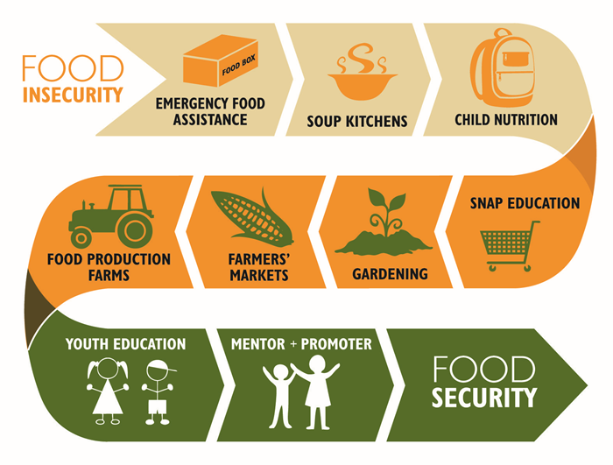
- Impacts on all forms of agricultural production will affect livelihoods and access to food. Producer groups that are less able to deal with climate change, such as the rural poor in developing countries, risk having their safety and welfare compromised.
Source www.fao.org
Other food system processes, such as food processing, distribution, acquisition, preparation and consumption, are as important for food security as food and agricultural production are. Technological advances and the development of long-distance marketing chains that move produce and packaged foods throughout the world at high speed and relatively low cost have made overall food system performance far less dependent on climate than it was 200 years ago.
However, as the frequency and intensity of severe weather increase, there is a growing risk of storm damage to transport and distribution infrastructure, with consequent disruption of food supply chains. The rising cost of energy and the need to reduce fossil fuel usage along the food chain have led to a new calculus – “food miles”, which should be kept as low as possible to reduce emissions. These factors could result in more local responsibility for food security, which needs to be considered in the formulation of adaptation strategies for people who are currently vulnerable or who could become so within the foreseeable future.

Food security and climate change: a conceptual framework
Climate change variables influence biophysical factors, such as plant and animal growth, water cycles, biodiversity and nutrient cycling, and the ways in which these are managed through agricultural practices and land use for food production. However, climate variables also have an impact on physical/human capital – such as roads, storage and marketing infrastructure, houses, productive assets, electricity grids, and human health – which indirectly changes the economic and socio-political factors that govern food access and utilization and can threaten the stability of food systems. All of these impacts manifest themselves in the ways in which food system activities are carried out. The framework illustrates how adaptive adjustments to food system activities will be needed all along the food chain to cope with the impacts of climate change. The climate change variables considered are:
- the CO2 fertilization effect of increased greenhouse gas concentrations in the atmosphere;
- increasing mean, maximum and minimum temperatures;
- gradual changes in precipitation: increase in the frequency, duration and intensity of dry spells and droughts;
- changes in the timing, duration, intensity and geographic location of rain and snowfall;
- increase in the frequency and intensity of storms and floods;
- greater seasonal weather variability and changes in start/end of growing seasons.
In addition, less immediate impacts are expected to result from gradual changes in mean temperatures and rainfall. These will affect the suitability of land for different types of crops and pasture; the health and productivity of forests; the distribution, productivity and community composition of marine resources; the incidence and vectors of different types of pests and diseases; the biodiversity and ecosystem functioning of natural habitats; and the availability of good-quality water for crop, livestock and inland fish production. Arable land is likely to be lost owing to increased aridity (and associated salinity), groundwater depletion and sea-level rise. Food systems will be affected by internal and international migration, resource-based conflicts and civil unrest triggered by climate change.

Potential impacts of climate change on food availability
Production of food and other agricultural commodities may keep pace with aggregate demand, but there are likely to be significant changes in local cropping patterns and farming practices. There has been a lot of research on the impacts that climate change might have on agricultural production, particularly cultivated crops. Some 50 percent of total crop production comes from forest and mountain ecosystems, including all tree crops, while crops cultivated on open, arable flat land account for only 13 percent of annual global crop production. Production from both rainfed and irrigated agriculture in dryland ecosystems accounts for approximately 25 percent, and rice produced in coastal ecosystems for about 12 percent (Millennium Ecosystem Assessment, 2005).
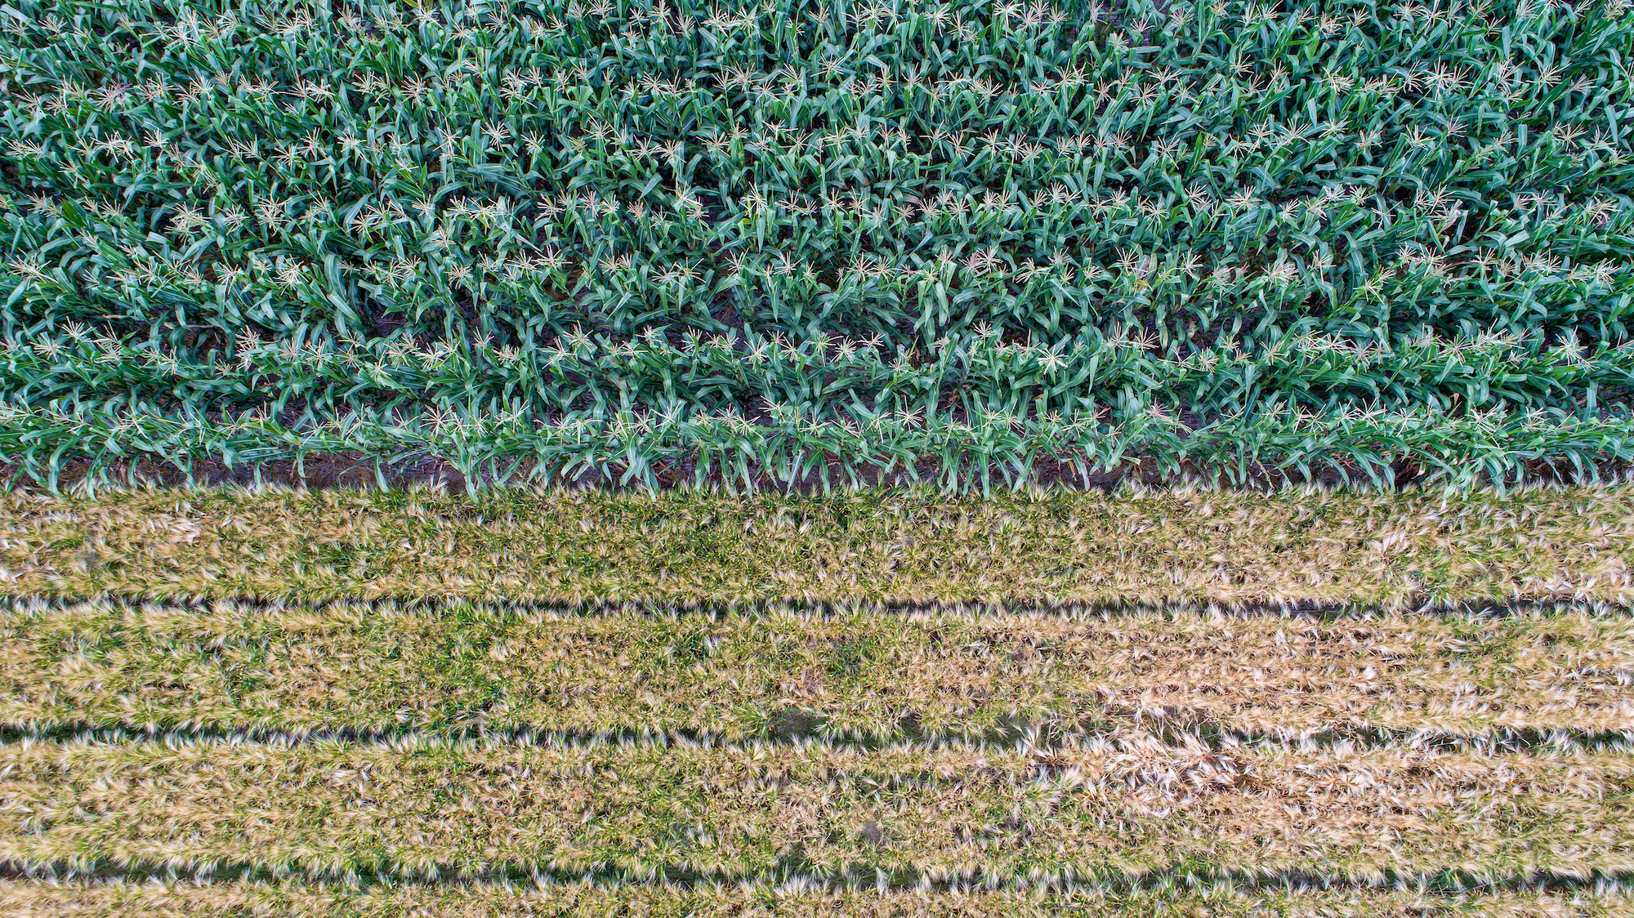
Creator: Alfonso Cortes / Copyright: CIMMYT Int.
The evaluation of climate change impacts on agricultural production, food supply and agriculture-based livelihoods must take into account the characteristics of the agro-ecosystem where particular climate-induced changes in biochemical processes are occurring, in order to determine the extent to which such changes will be positive, negative or neutral in their effects.
The so-called “greenhouse fertilization effect” will produce local beneficial effects where higher levels of atmospheric CO2 stimulate plant growth. This is expected to occur primarily in temperate zones, with yields expected to increase by 10 to 25 percent for crops with a lower rate of photosynthetic efficiency (C3 crops), and by 0 to 10 percent for those with a higher rate of photosynthetic efficiency (C4 crops), assuming that CO2 levels in the atmosphere reach 550 parts per million (IPCC, 2007c); these effects are not likely to influence projections of world food supply, however (Tubiello et al., 2007). Mature forests are also not expected to be affected, although the growth of young tree stands will be enhanced (Norby et al., 2005).
The impacts of mean temperature increase will be experienced differently, depending on location (Leff, Ramankutty and Foley, 2004). For example, moderate warming (increases of 1 to 3 ºC in mean temperature) is expected to benefit crop and pasture yields in temperate regions, while in tropical and seasonally dry regions, it is likely to have negative impacts, particularly for cereal crops. Warming of more than 3 ºC is expected to have negative effects on production in all regions (IPCC, 2007c). The supply of meat and other livestock products will be influenced by crop production trends, as feed crops account for roughly 25 percent of the world’s cropland.
For climate variables such as rainfall, soil moisture, temperature and radiation, crops have thresholds beyond which growth and yield are compromised (Porter and Semenov, 2005). For example, cereals and fruit tree yields can be damaged by a few days of temperatures above or below a certain threshold (Wheeler et al., 2000). In the European heat wave of 2003, when temperatures were 6 ºC above long-term means, crop yields dropped significantly, such as by 36 percent for maize in Italy, and by 25 percent for fruit and 30 percent for forage in France (IPCC, 2007c). Increased intensity and frequency of storms, altered hydrological cycles, and precipitation variance also have long-term implications on the viability of current world agroecosystems and future food availability.
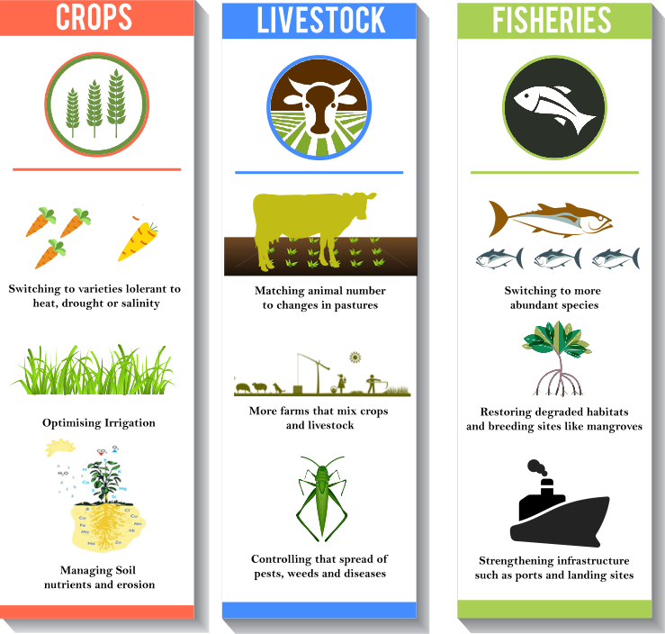
Wild foods are particularly important to households that struggle to produce food or secure an income. A change in the geographic distribution of wild foods resulting from changing rainfall and temperatures could therefore have an impact on the availability of food. Changes in climatic conditions have led to significant declines in the provision of wild foods by a variety of ecosystems, and further impacts can be expected as the world climate continues to change. For the 5 000 plant species examined in a sub-Saharan African study (Levin and Pershing, 2005), it is predicted that 81 to 97 percent of the suitable habitats will decrease in size or shift owing to climate change. By 2085, between 25 and 42 percent of the species’ habitats are expected to be lost altogether. The implications of these changes are expected to be particularly great among communities that use the plants as food or medicine. Constraints on water availability are a growing concern, which climate change will exacerbate. Conflicts over water resources will have implications for both food production and people’s access to food in conflict zones (Gleick, 1993). Prolonged and repeated droughts can cause loss of productive assets, which undermines the sustainability of livelihood systems based on rainfed agriculture.
Source Climate change and food security – The Institute for Policy, Advocacy, and Governance (ipag.org)
For example, drought and deforestation can increase fire danger, with consequent loss of the vegetative cover needed for grazing and fuelwood (Laurence and Williamson, 2001Food production varies spatially, so food needs to be distributed between regions. The major agricultural production regions are characterized by relatively stable climatic conditions, but many food-insecure regions have highly variable climates. The main grain production regions have a largely continental climate, with dry or at least cold weather conditions during harvest time, which allows the bulk handling of harvested grain without special infrastructure for protection or immediate treatment.
Sources
http://www.fao.org/3/k2595e/k2595e00.pdf
https://www.metoffice.gov.uk/food-insecurity-index/

